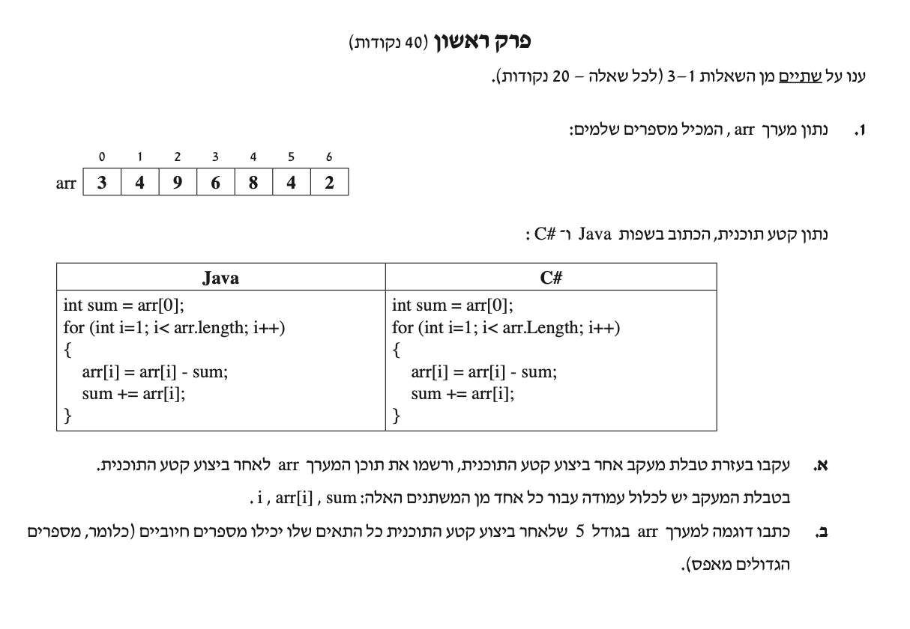

arr
arr.length = 7
position | 0 | 1 | 2 | 3 | 4 | 5 | 6
Initial | 3 | 4 | 9 | 6 | 8 | 4 | 2
progress | 3 | 1Track | 5 | -3 | 2 | -4 | -2

 | i | sum | arr[i] = arr[i]-sum
 |  | A | B
Init |  | 3
 | 1 | 3 + 1 = 4 | 4 - 3 = 1
 | 2 | 4 + 5 = 9 | 9 – 4 = 5
 | 3 | 9 + (-3) = 6 | 6 – 9 = -3
 | 4 | 6 + 2 = 8 | 8 – 6 = 2
 | 5 | 8 + (-4) = 4 | 4 – 8 = -4
 | 6 | 4 + (-2) = 2 | 2 – 4 = -2

